**Project Plan 1**

*Kelly Brichta*

This app is one to help aid in language learning through music and lyrics. Basically, while listening to a song, the user will have the lyrics on this screen and be able to fill in the blanks of the missing words to test their listening skills. Each blank will have a button that shows a clue to what that word is. I will begin with one song because I still need to research what it possible with the knowledge I know and can learn in XCode.

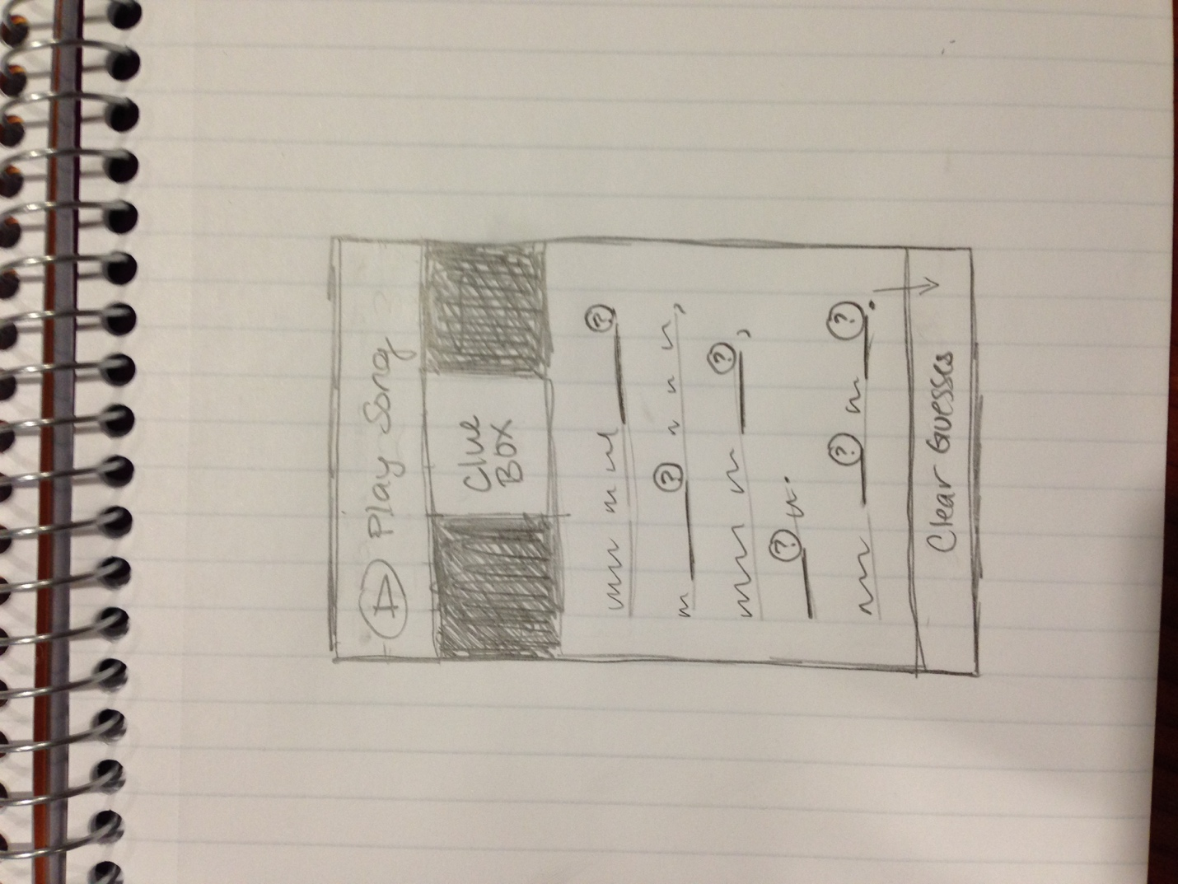

**Pseudo code**

User plays and pauses song within app either through iTunes or Spotify framework?

*It may be necessary to leave the source of the music to play via a different app and or device.

When a user clicks Song 1, Song 2, or Song 3:

Lyrics appear in the window with periodic blanks where the user can fill in their answer.

If the blank is filled in with the **correct** answer, then the user will be alerted that it is **correct**.

If the blank is filled in with the **incorrect** answer, then the user will be alerted that is is **incorrect**.

If the user does not know what to fill in at all, they can click the clue button next to the blank to receive a clue (an image) in the **Clue Box**.

When a user clicks Clear:

Blanks reset and user can listen again and start the guesses over.